**How to make Origami Suriken**

This is composed of eight congruent segments.

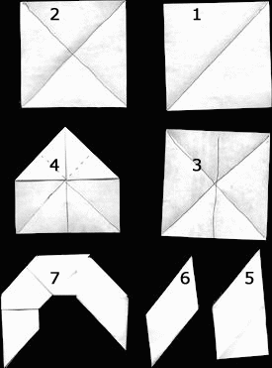

Follow the steps to make the segments you see in the lower right hand corner. The segments interlock as shown in the left hand corner.

The last piece is the hardest to lock in, but it folds in just like all the others.

[OpenClosed](javascript:)When you are finished locking them together you should have a donut looking item like the picture below: